EWNB11-C36 Series Specifications

1.0 Scope

1.1 This specification, in combination with pump data sheets, identifies the minimum requirements for electronic metering pumps.

2.0 Reference codes and standards

2.1 Pumps shall comply with the latest editions of the following codes and standards:

UL Standard 778

NEMA 4X (IP65)
Hydraulic Institute Standards

National Electric Code

3.0 Definitions

3.1 Electronic metering pump - A positive displacement diaphragm metering pump in which the diaphragm is actuated by an electromagnetic solenoid which is in turn controlled by an electronic circuit.

4.0 General

4.1 Output volume shall be adjustable while pump is in operation.

4.2 Weight of pump as installed shall not exceed 14 pounds.

4.3 Pump shall fit within a rectangular volume 10.5” long by 4.6” wide by 8.5” high.

5.0 Drive

5.1 The pump mechanism shall be totally enclosed with no exposed moving parts.

5.2 Electronic control module shall be located opposite the liquid end and protected by a clear cover.

5.3 Average power consumption shall not exceed 24 watts under full speed and maximum pressure conditions.

5.4 Metering pump shall be capable of pumping a maximum of (q) GPH against a maximum pressure of (p) PSI. (q and p from Table 1)

5.5 Stroke length shall be adjustable from 20% to 100% by means of a readily accessible knob.

5.6 Control of pump speed shall be selectable between manual and external by means of push buttons.

In manual mode, pump speed of standard models shall be adjustable from 1 to 360 strokes per minute by means of a readily accessible keypad with digital display.

Pump shall be able to be stopped and started by means of push buttons.

EWN Pumps with “R” Control Option:

Pump shall be able to display the pump’s output in percent speed, gallons per hour, liters per hour, or mL per min. A calibration must be performed to accurately display a flowrate output on the display.

In external analog mode, the pump shall accept a 0-20 mA control signal from external equipment and operate at a speed that is proportional to the signal level. The slope and zero offset of the pump’s response shall be operator adjustable by means of push buttons.

In external digital mode, the pump shall respond to a pulse signal from external equipment such that either one pulse produces n pump strokes (multiply mode) or n pulses produce one pump stroke (divide mode). In either mode n shall be operator adjustable from 1 to 9999 by means of push buttons.

Pump shall include an external stop input that can be set to stop the pump from a normally open or normally closed contact. A red light will visibly indicate a stopped condition. Pump shall also include a pre-stop input contact from a normally open or normally closed contact that will not stop the pump. An orange light will visibly indicate a pre-stop condition.

Pump has a low voltage relay output selectable by means of push buttons to close synchronously with pump operation or close with the STOP input signal.

Pump shall include a priming function that enables the pump to operate at full speed without changing the programmed values or control mode.

Pump keypad shall be lockable to prevent tampering.

EWN Pumps with “Y” Control Option:

Include all “R” Control Options above plus:

Pump shall also be able to display the output in SPM.

In external Batch mode, the pump will output a programmed volume with each incoming pulse. Volume of output is programmed by means of push buttons.

Pump shall be able to accept a digital input directly from a PosiFlow Flow Sensor, compare it to pump operation, and activate an alarm relay if the pump loses prime or if the pump’s discharge line is cut, resulting in a loss of discharge pressure. Pump will have several adjustable control programs accessible through push buttons to set interaction of pump, sensor and alarms.

Pump shall be able to auto-detect and accept the input directly from an EFS magnetic flow sensor for the self-correction of pump speed and adjust operation to achieve desired flow output. Several additional alarm criteria shall be available with the EFS Sensor and conditions can be programmed through push buttons.

Pump shall be equipped with a mechanical relay that can be activated by a stop, pre-stop, or interlock input in addition to a batch completion, or an alarm condition related to a PosiFlow or EFS Sensor input. Programming of the mechanical relay output is done using push buttons.

Pump shall have a low voltage relay that can be activated to function synchronous with a flow sensor, synchronous with pump operation, upon a batch completion, with an alarm condition related to a PosiFlow or EFS Sensor input, or activated with a stop, pre-stop, or interlock input. Programming of the low voltage relay output is done using push buttons.

Pump shall have a programmable 0-20mA output control signal to relay output proportional to flowrate of the pump.

Input and output logic is programmable normally open or normally closed.

Pump shall retain data relating to pump operation, total flow, number of relay contacts, power on time, and powered operational time. This data can be viewed on the pump by means of push buttons.

6.0 Materials of construction

6.1 Pump housing shall be made of chemically resistant Polyphenyl Ether (PPE).

6.2 All exposed metal fasteners shall be 316 stainless steel.

6.3 Liquid end materials of construction shall be as shown in Table 2.

7.0 Shop tests

7.1 All pumps shall pass manufacturer’s standard performance tests.

Table 1 Capacity/Pressure Rating

Size | Maximum Output Capacity (q) |  | Output per Stroke (mL) |  | Maximum Pressure (p) |  | Connection Size Tubing O.D.¹
 | Gal/hr | mL/min | Min | Max | PSI | MPa | in
B09-C | 0.2 | 12 | 0.007 | 0.03 | 150 | 1.0 | 3/8”
B11 | 0.6 | 38 | 0.021 | 0.11 | 150 | 1.0
B11-A | 0.5 | 30 | 0.017 | 0.08 | 150 | 1.0
B11-C | 0.4 | 23 | 0.026 | 0.13 | 150 | 1.0
B11-H | 0.4 | 25 | 0.021 | 0.10 | 250 | 1.7
B11-H2 | 0.3 | 17 | 0.050 | 0.07 | 290 | 2.0
B16 | 1.0 | 65 | 0.035 | 0.18 | 105 | 0.7
B16-A | 0.9 | 55 | 0.031 | 0.15 | 105 | 0.7
B16-C | 0.6 | 40 | 0.044 | 0.22 | 105 | 0.7
B21 | 1.6 | 100 | 0.056 | 0.28 | 60 | 0.4
B21-A | 1.4 | 86 | 0.048 | 0.24 | 60 | 0.4
B21-C | 1.0 | 63 | 0.070 | 0.35 | 60 | 0.4
B31 | 3.2 | 200 | 0.111 | 0.56 | 30 | 0.2 | 1/2”
C16 | 1.3 | 80 | 0.046 | 0.22 | 150 | 1.0 | 3/8”
C16-A | 1.0 | 65 | 0.036 | 0.18 | 150 | 1.0
C16-C | 0.9 | 54 | 0.060 | 0.30 | 150 | 1.0
C16-H | 0.6 | 40 | 0.033 | 0.17 | 250 | 1.7
C21 | 2.1 | 130 | 0.072 | 0.36 | 105 | 0.7
C21-A | 1.7 | 110 | 0.061 | 0.31 | 105 | 0.7
C21-C | 1.2 | 78 | 0.087 | 0.43 | 105 | 0.7
C31 | 4.3 | 270 | 0.151 | 0.75 | 50 | 0.35 | 1/2”
C31-V | 2.4 | 150 | 0.125 | 0.63 | 73 | 0.5 | ½”OD x ½” Barb
C36² | 6.7 | 420 | 0.235 | 1.17 | 30 | 0.2 | 1/2”
- ¼” NPT female for 316SS
- Output of the EKC36-TC/FC/SH is 6.5 Gal/hr (410 mL/min)

Table 2 Materials of Construction

Liquid End | Pump Head & Fittings | Diaphragm | Valve Balls | Valve Seat | Valve Seals | Gasket | Tubing
FC | PVDF | PTFE bonded to EPDM | CE | PCTFE | PTFE | PTFE | PE
TC | PVDF |  | CE | FKM | FKM
TA | PVDF |  | CE | PCTFE | AFLA®
PC | GFRPP |  | CE | FKM | FKM
PE | GFRPP |  | CE | EPDM | EPDM
PA | GFRPP |  | CE | PCTFE | AFLAS®
VC(A) | PVC |  | CE | FKM | FKM
VE | PVC |  | CE | EPDM | EPDM
VF | PVC |  | PTFE | EPDM | EPDM
SH | 316SS |  | HC | 316SS | PTFE |  | ¼” NPTF

CE Alumina ceramic EPDM Ethylene propylene diene monomer
FKM Fluoroelastomer GFRPP Glass fiber reinforced polypropylene
HC Hastelloy C276 PCTFE Polychlorotrifluoroethylene
PE Polyethylene PTFE Polytetrafluoroethylene
PVC Polyvinylchloride (translucent) PVDF Polyvinylidenefluoride
316SS 316 stainless steel AFLAS® Tetrafluoroethylene and propylene copolymer
Dimensions

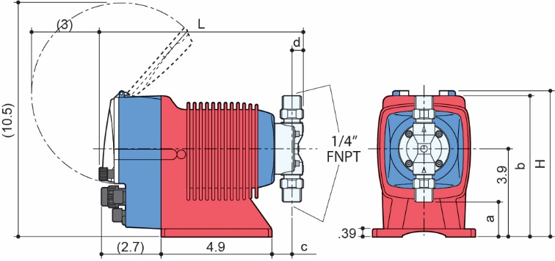  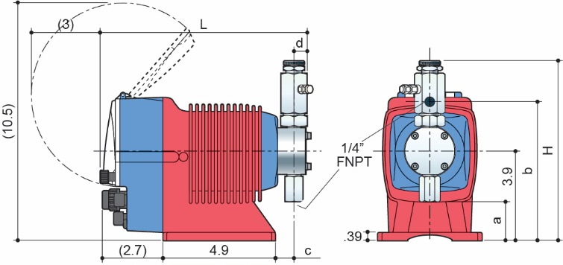  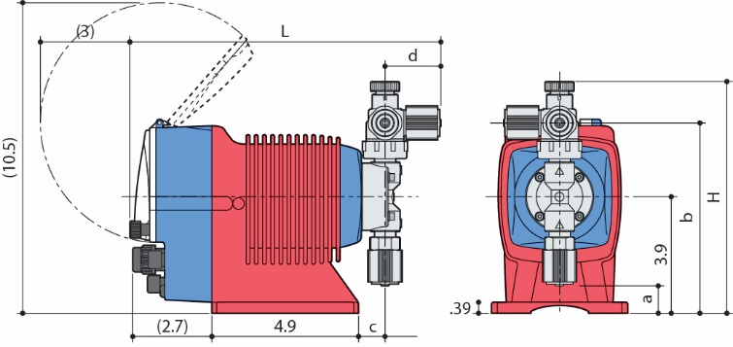 | 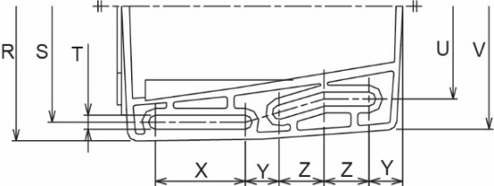  PC / PE / PA / Models  VC / VE / VF /  TC / TA  SH Models  (SHN not shown)  FC Models  Mounting Dimensions  Bottom View
Dimensions (inches)
Material | Model | H | L | a | b | c | d
PC / PE / PA / VC / VE / VF /  TC / TA | EWN-11,16, 21 | 7.83 | 10.43 | 0.94 | 6.45 | 0.90 | 1.85
 | EWN-31 | 8.34 | 10.51 | 0.23 | 6.97 | 0.98 | 1.89
 | EWN-36 | 8.30 | 10.51 | 0.27 | 6.93 | 0.94 | 1.89
SH | EWN-11,16, 21 | 7.91 | 9.13 | 1.73 | 6.10 | 0.86 | 0.59
 | EWN-31 | 8.38 | 9.17 | 1.34 | 6.49 | 0.90 | 0.59
 | EWN-36 | 8.50 | 9.17 | 1.26 | 6.69 | 0.90 | 0.59
FC  NOTES: | EWN-11,16, 21 | 6.53 | 9.09 | 1.57 | 6.31 | 0.90 | 0.51
 | EWN-31 | 6.97 | 9.29 | 0.90 | 6.97 | 0.98 | 0.63
 | EWN-36 | 6.97 | 9.25 | 0.90 | 6.97 | 0.94 | 0.63
- Addition of a Multifunction Valve increases overall length by 0.10”
- Addition of a Multifunction Valve increases discharge height by 2.62”.
Addition of the Auto Degassing Valve increases discharge height by 1.82”.
- Addition of a Multifunction Valve increases overall liquid end height by 1.25”. Addition of the Auto Degassing Valve increases overall liquid end height by 1.82”.

Mounting Dimensions (inches)
EW Model | R | S | T | U | V | X | Y | Z
11,16,21 | 4.57 | 3.94 | 0.24 | 3.15 | 4.17 | 1.57 | 0.59 | 0.79
31,36

